~~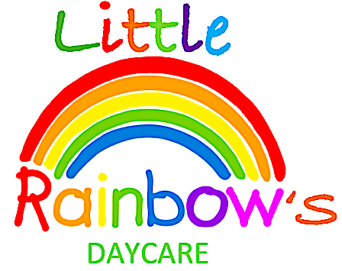~~

SERIES 1 | 1

On behalf of the little rainbows Daycare team, we would like to give a very big thank you to all the parents and children that attended our open day on Saturday 23rd June 2018, it was lovely to get to know our community, and we hope to see you again.



**Upcoming Events**

**Summer half term:**

**16th July 2018 - 30th July 2018**

**All throughout the month of July we will be hosting open evenings, this is for new parents and carers. If you would like to attend, please contact Sharon on 07496323369 for an appointment time**

Nathan is star of the week

**AWARDS OF THE MONTH:**

Nathan achieved a star of the week award for remaining on our happy face chart and keeping up the good work with his toilet training.

Dear all parents and carers, Little Rainbows Daycare would like to introduce our first newsletter of 2018. Every term we will providing you with our upcoming events and new.